# Hunter Estuary KBA, New South Wales

BirdLife Australia Key Biodiversity Area (KBA) Change Detection Report, September 2003 – September 2023

Prepared for [BirdLife Australia](https://birdlife.org.au/) by [Michael Dear](https://mjdear68.github.io/portfolio/), June 2024

## Links

[Hunter Estuary BirdLife Factsheet](https://www.keybiodiversityareas.org/site/factsheet/23838)

## Glossary

Mean: the average of a set of numbers.

Normalised Difference Vegetation Index (NDVI): The NDVI is a common remote sensing index used for the assessment of vegetation cover and vigour. The NDVI has values in the range of -1 to 1. Values below 0 are generally associated with deep water. Values above 0.8 are associated with dense forest.

Normalised Burn Ratio (NBR): The NBR is used primarily for assessment of fire extent and severity. It is also a useful indicator of healthy vegetation and bare ground.

Normalised Difference Water Index (NDWI): The NDWI is used primarily to detect water.

Masked: Pixels that were excluded from the dataset due to a lack of data e.g. cloud cover

Random Forest: A machine learning algorithm often used for land cover classification.

Support Vector Machine: A machine learning algorithm often used for land cover classification.

## Key Points

* The Hunter Estuary KBA covers an area of ha.
* The study area covered an area of ha.
* There has been substantial urban development along the study area boundary during the study period.
* The tidal gates at the eastern edge of the Hexham Swamp were opened permanently beginning in 2008 (["Floodgates finally open, ending decades of damage - ABC News"](https://www.abc.net.au/news/2013-07-25/floodgates-finally-open2c-ending-decades-of-damage/4842140)).
* The proportion of Wooded vegetation in the study area increased from 19.1% to 24.5% during the study period.

## Method

The study area was developed by applying a 1000 metre exterior buffer to the KBA. A bi-temporal pair of Landsat 8 satellite images based on the mean of two dates in September 2003 and two dates in September 2023 was obtained from [Digital Earth Australia's](https://www.dea.ga.gov.au/) Open Data. Each in the study area was represented by one pixel in the dataset. The dataset included the red, green, blue, near-infrared, shortwave infrared 1, and shortwave infrared 2 bands, plus the NDVI, NBR, and NDWI indices. A classification with the classes No Data, Water, Developed, Green Grass, Brown Grass, Swamp, and Wooded was established.

Colour-composite and NDVI images were used to develop training and test sets for each of the two dates. Four different classifications for each date were made using supervised machine learning algorithms. The algorithms were random forest (RF) and support vector machine (SVM) with three different kernels (linear, polynomial, and radial basis function (RBF)). The models were trained on 429 samples and tested on 107 samples in each class for each date. This represented an 80:20 split of the candidate sample dataset. A 3x3 sliding window modal filter was applied to the classifications to reduce noise.

The four classifications were compared visually using QGIS and high-resolution imagery obtained from the [NSW Historical Imagery Viewer](https://portal.spatial.nsw.gov.au/portal/apps/webappviewer/index.html?id=f7c215b873864d44bccddda8075238cb) and Google Earth. It was determined that the SVM with a linear kernel represented the most accurate classification when applied to the whole study area. Post-classification analysis was applied to the classifications for the two dates to establish class change statistics.

## Site

The Hunter Estuary KBA is in Newcastle, NSW, at latitude and longitude . The majority of the KBA is contained within the Hunter Wetlands National Park, however, areas immediately adjacent to the KBA are being increasingly developed for industry, major roads, and urban development.

### Long-term Monthly Rainfall and Mean Temperature

The monthly mean maximum and minimum temperatures and total monthly rainfall for the period 2003 – 2023 was obtained from the Bureau of Meteorology (BoM) automatic weather station (AWS) at Nobby’s Lighthouse (AWS#: 061055). The maximum and minimum temperatures for each month were averaged to produce a mean average monthly temperature variable. The plot of rainfall and temperature (Figure 1) indicates that there is a moderate seasonal variation in temperature with cooler conditions in winter. The autumn and early winter months are wetter than spring and early summer.

Figure 1  
Long-term Monthly Rainfall and Mean Temperature.

### True colour (RGB) Plots

The plots in Figure 2 show a true-colour representation of the KBA and its surrounds. The study area (KBA + 1000m buffer) boundary is shown in blue. The increase in urban development is prominent in the southern part of the study area.

Figure 2  
True colour (RGB) Plots.

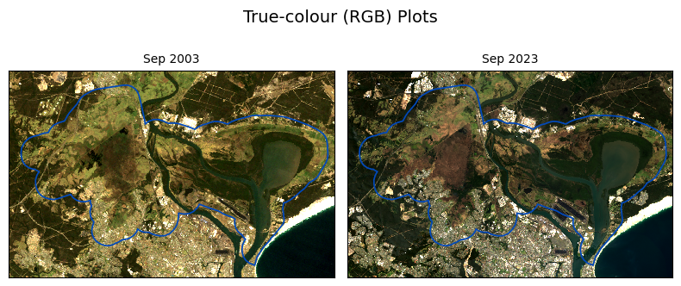

### Shortwave Infrared 1, Near Infrared, Red Plots

The plots in Figure 3 show water as black, denser, woody vegetation as green, drier grassy vegetation as light brown and orange, and buildings as light pink. Differences in drier vegetation within the Hexham swamp between the two dates are evident. There is also a substantial difference in the extent of water and woody vegetation evident along the eastern edge of Hexham swamp associated with the opening of the tidal gates since 2008.

Figure 3  
Shortwave Infrared 1, Near Infrared, Red Plots.

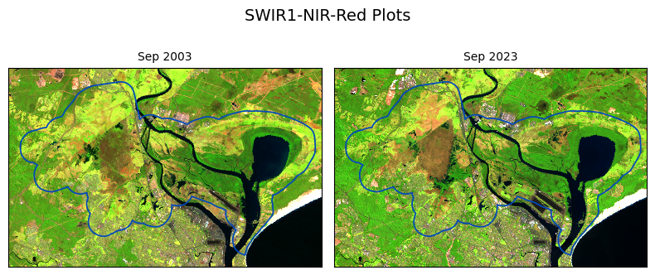

## Land Cover Classification

### Support Vector Machine (SVM) Classification Plots

The Support Vector Machine classification plots (Figure 4) highlight the increase in urban area and the vegetation change in the east of Hexham Swamp. Close inspection also indicates areas in which woody vegetation has extended in North Arm Cove and Kooragang Island. There is substantial change between green and brown grass to the north-west of Hexham Swamp, which could be due to seasonal differences in rainfall. However, changes in drainage patterns should be investigated, particularly in light of the construction of the [Pacific Highway interchange](https://www.transport.nsw.gov.au/projects/current-projects/pacific-highway-improvements-at-hexham) in that area.

Figure 4  
Support Vector Machine classification plots.

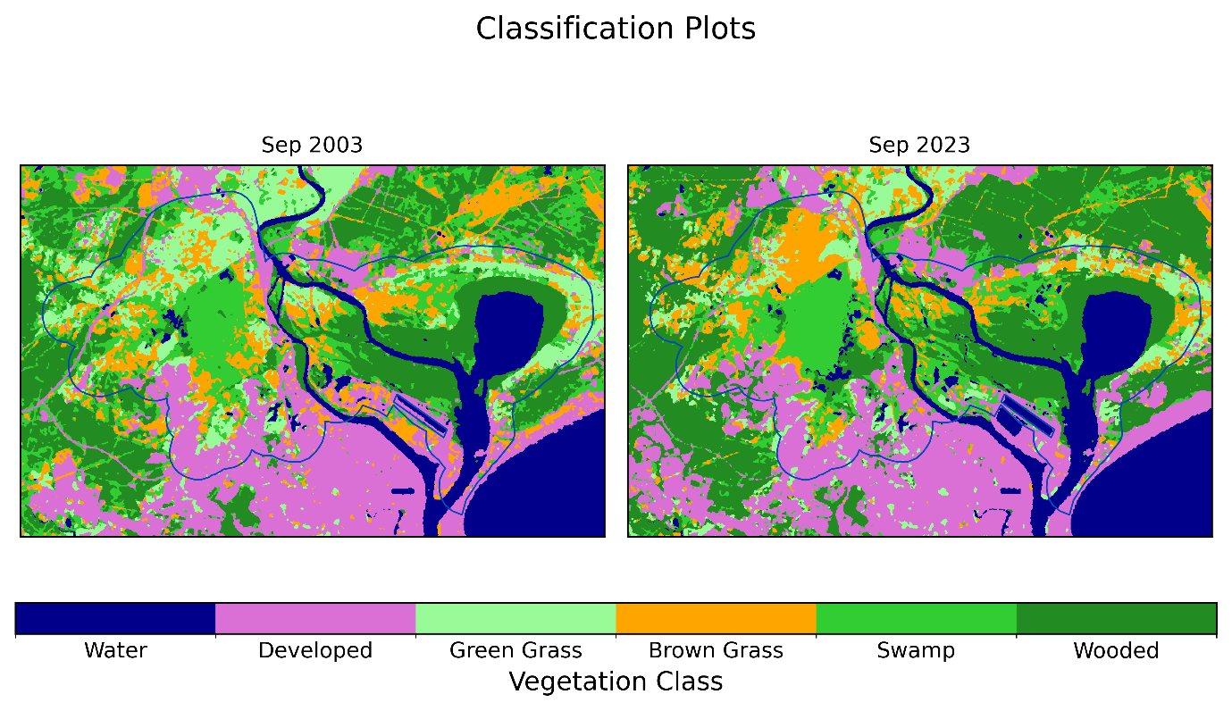

## Model Accuracy

The overall accuracy of each SVM classification was high (Table 1), indicating the usefulness of the method for classifying land cover in the KBA.

Table 1  
Overall accuracy (correct classification) for each time step.

|  |  |
| --- | --- |
|  | **Accuracy** |
| **Sep 2003** | 97.6% |
| **Sep 2023** | 98.4% |

From the confusion matrices (Table 2 and Table 3) it can be observed that there was some confusion between Brown Grass, Green Grass, and Swamp for each date. Wooded was confused with Swamp to a minor extent in Sep 2003.

Table 2  
Confusion matrix for Sep 2003.

|  |  |  |  |  |  |  |  |
| --- | --- | --- | --- | --- | --- | --- | --- |
|  | **No Data** | **Water** | **Developed** | **Green Grass** | **Brown Grass** | **Swamp** | **Wooded** |
| **No Data** | 108 | 0 | 0 | 0 | 0 | 0 | 0 |
| **Water** | 0 | 108 | 0 | 0 | 0 | 0 | 0 |
| **Developed** | 0 | 0 | 105 | 0 | 2 | 0 | 0 |
| **Green Grass** | 0 | 0 | 0 | 107 | 0 | 1 | 0 |
| **Brown Grass** | 0 | 0 | 1 | 3 | 103 | 0 | 0 |
| **Swamp** | 0 | 0 | 0 | 4 | 1 | 100 | 2 |
| **Wooded** | 0 | 0 | 0 | 0 | 0 | 4 | 103 |

Table 3  
Confusion matrix for Sep 2023.

|  |  |  |  |  |  |  |  |
| --- | --- | --- | --- | --- | --- | --- | --- |
|  | **No Data** | **Water** | **Developed** | **Green Grass** | **Brown Grass** | **Swamp** | **Wooded** |
| **No Data** | 108 | 0 | 0 | 0 | 0 | 0 | 0 |
| **Water** | 0 | 107 | 0 | 0 | 0 | 0 | 1 |
| **Developed** | 0 | 0 | 106 | 1 | 0 | 0 | 0 |
| **Green Grass** | 0 | 0 | 0 | 108 | 0 | 0 | 0 |
| **Brown Grass** | 0 | 0 | 0 | 0 | 104 | 3 | 0 |
| **Swamp** | 0 | 0 | 0 | 0 | 7 | 100 | 0 |
| **Wooded** | 0 | 0 | 0 | 0 | 0 | 0 | 107 |

## Class Change

The increase in the Developed and Wooded and decrease in the Green Grass classes is evident from the results in Table 4. Table 5 indicates that the Wooded class increased by 28.4% from 2003 to 2023, whereas Green Grass decreased by 44.7%.

Table 4  
Area (ha) of the study area per class.

|  |  |  |  |  |  |  |  |  |
| --- | --- | --- | --- | --- | --- | --- | --- | --- |
|  | **No Data** | **Water** | **Developed** | **Green Grass** | **Brown Grass** | **Swamp** | **Wooded** | **Total** |
| **Sep 2003** | 0.0 | 1837.62 | 2800.62 | 2442.15 | 2329.2 | 3228.57 | 2980.08 | 15618.2 |
| **Sep 2023** | 0.0 | 1983.15 | 2861.82 | 1351.17 | 2356.2 | 3240.90 | 3825.00 | 15618.2 |

Table 5  
Total change (ha) and percentage change in each class.

|  |  |  |  |  |
| --- | --- | --- | --- | --- |
|  | **Sep 2003** | **Sep 2023** | **Sep 2023-Sep 2003** | **Change_%** |
| **No Data** | 0.00 | 0.00 | 0.00 | NaN |
| **Water** | 1837.62 | 1983.15 | 145.53 | 7.9 |
| **Developed** | 2800.62 | 2861.82 | 61.20 | 2.2 |
| **Green Grass** | 2442.15 | 1351.17 | -1090.98 | -44.7 |
| **Brown Grass** | 2329.20 | 2356.20 | 27.00 | 1.2 |
| **Swamp** | 3228.57 | 3240.90 | 12.33 | 0.4 |
| **Wooded** | 2980.08 | 3825.00 | 844.92 | 28.4 |

The class change matrices in Table 6 and Table 7 suggest that approximately 18% of the area classified as Developed in 2003 was classified as Green Grass, Brown Grass, and Swamp in 2023. This is in part due to the inclusion of bare ground in the Developed class, some of which was revegetated during the study period. An example of this can be seen near the Kooragang Island coal loaders (Figure 5). Conversely, approximately 24% of the Developed class in Sep 2023 came from Green Grass, Brown Grass, and Swamp, possibly due to the expansion of urban areas.

Table 6  
Class change matrix (ha).

|  |  |  |  |  |  |  |  |  |
| --- | --- | --- | --- | --- | --- | --- | --- | --- |
|  |  | **Sep 2023** | | | | | | |
|  |  | **No Data** | **Water** | **Developed** | **Green Grass** | **Brown Grass** | **Swamp** | **Wooded** |
| **Sep 2003** | **No Data** | 0.0 | 0.00 | 0.00 | 0.00 | 0.00 | 0.00 | 0.00 |
| **Water** | 0.0 | 1730.25 | 10.08 | 1.44 | 0.99 | 62.46 | 32.40 |
| **Developed** | 0.0 | 30.24 | 2199.78 | 132.93 | 92.34 | 278.82 | 66.51 |
| **Green Grass** | 0.0 | 3.51 | 168.93 | 914.94 | 1063.62 | 220.05 | 71.10 |
| **Brown Grass** | 0.0 | 38.34 | 325.44 | 220.05 | 944.10 | 632.07 | 169.20 |
| **Swamp** | 0.0 | 108.36 | 101.34 | 75.69 | 245.52 | 1839.78 | 857.88 |
| **Wooded** | 0.0 | 72.45 | 56.25 | 6.12 | 9.63 | 207.72 | 2627.91 |

Table 7  
Class change matrix (%).

|  |  |  |  |  |  |  |  |  |
| --- | --- | --- | --- | --- | --- | --- | --- | --- |
|  | **Period** | **Sep 2023** | | | | | | |
|  | **Class** | **No Data** | **Water** | **Developed** | **Green Grass** | **Brown Grass** | **Swamp** | **Wooded** |
| **Sep 2003** | **No Data** | NaN | NaN | NaN | NaN | NaN | NaN | NaN |
| **Water** | 0.0 | 94.2 | 0.5 | 0.1 | 0.1 | 3.4 | 1.8 |
| **Developed** | 0.0 | 1.1 | 78.5 | 4.7 | 3.3 | 10.0 | 2.4 |
| **Green Grass** | 0.0 | 0.1 | 6.9 | 37.5 | 43.6 | 9.0 | 2.9 |
| **Brown Grass** | 0.0 | 1.6 | 14.0 | 9.4 | 40.5 | 27.1 | 7.3 |
| **Swamp** | 0.0 | 3.4 | 3.1 | 2.3 | 7.6 | 57.0 | 26.6 |
| **Wooded** | 0.0 | 2.4 | 1.9 | 0.2 | 0.3 | 7.0 | 88.2 |

Figure 5  
SVM classifications and true colour (Google Earth) images of bare-ground revegetation.

|  |  |  |
| --- | --- | --- |
| Sep 2003 Classification | Sep 2023 Classification | Jan 2022 True colour |
|  |  |  |